**Vijay R. Chaudhari** (M.Sc., Ph.D.)

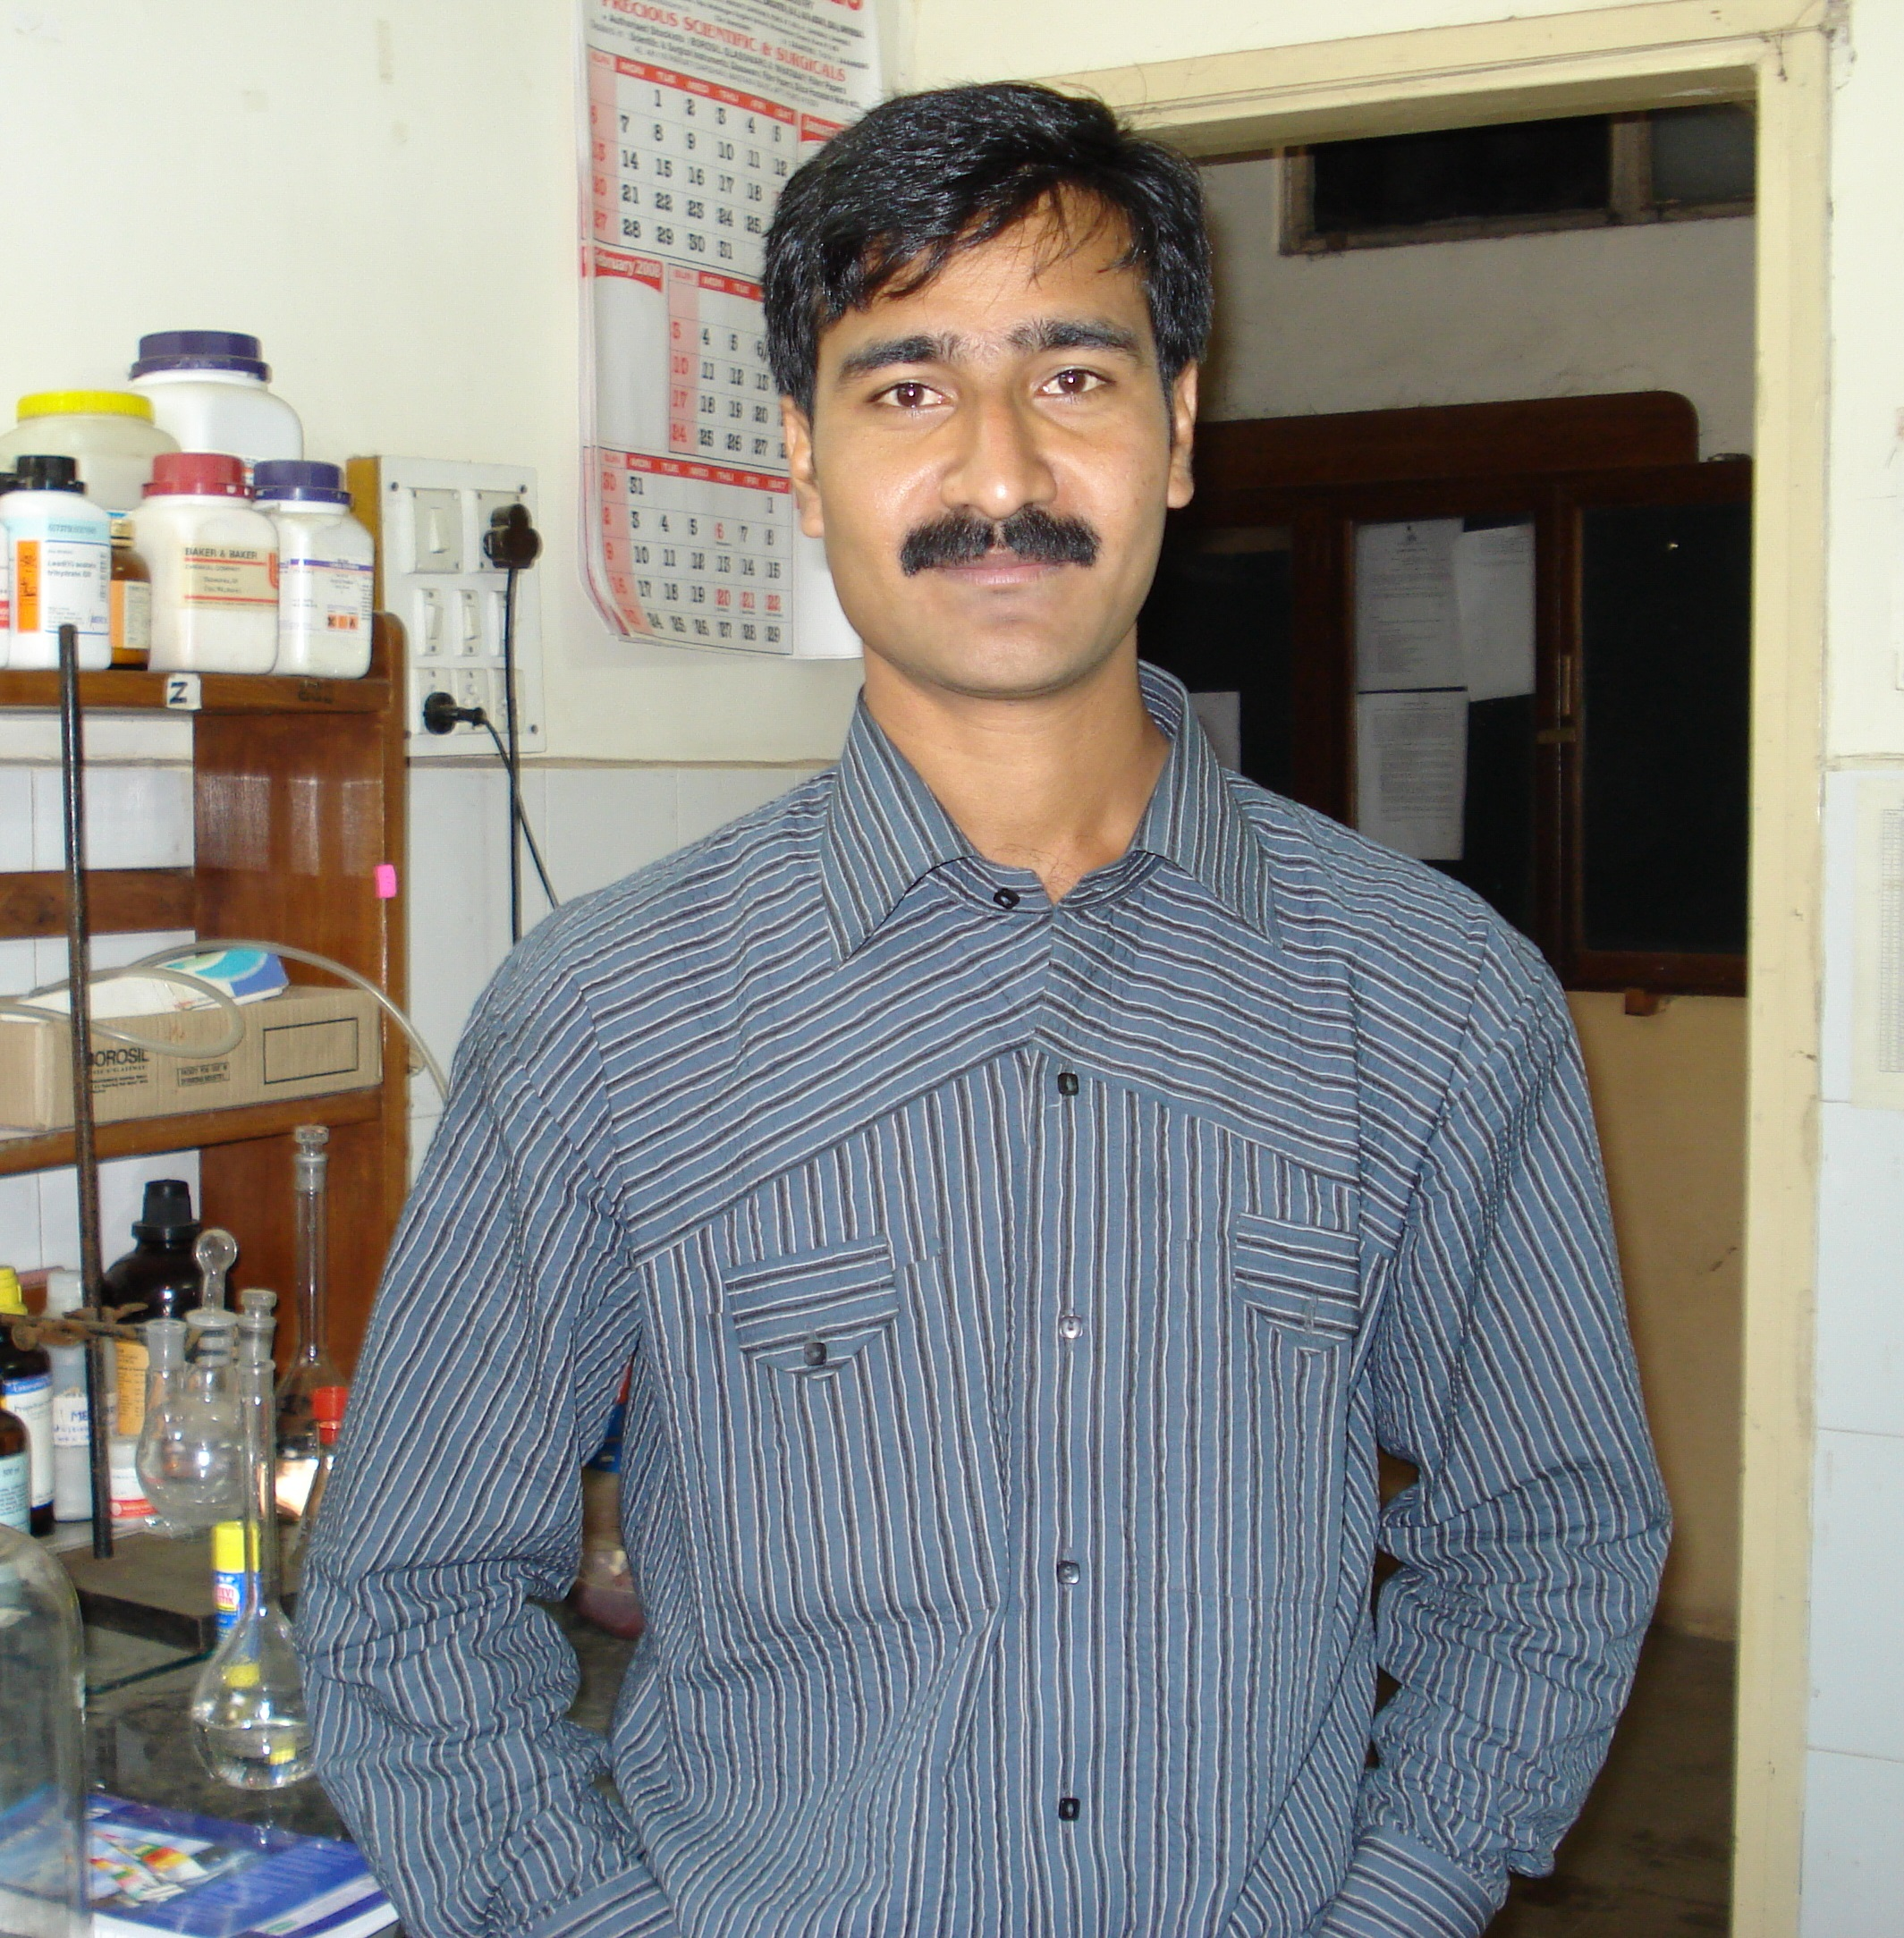

Room No. 293, Physical and Material Chemistry Division, National Chemical Laboratory, Homi Bhabha Road, Pashan, Pune – 411 008.

+919765259537│vijay.rchaudhari@gmail.com│v.chaudhari@ncl.res.in.



### Profile:

 I have fifteen years of research experience in the field of material chemistry with an emphasis on **electrochemical, catalytic**, optical properties of nano-materials, as well as Self Assembled Monolayer (SAM) preparation and characterization. I can design and synthesize the materials with desired catalytic/electro-catalytic properties specially for improve processes those are important for industrial sector as well energy production (e.g. HER, ORR, Methanol oxidation). I also investigated the molecular electrochemical behavior those are important fundamentally and technologically. Moreover, I can design, pursue and manage the project independently as well as jointly. I am also working on design the synthetic methodology for scale up production of nanomaterials. (*For Detail research experience please refer* ***Annexure I***)

**Academic Record:**

**Ph. D (Chemistry)** Pune University (October 2009)

**(**Advisor:Prof. S. K. Haram**)**

**Master in Science**: Passed with First class from University of Pune,

**(Physical Chemistry)** India (June 2003).

**Bachelor in Science:** Passed with First class with distinction from North

**(Chemistry)**  Maharashtra University, India, in June, 2001.

**Research Expertise**:

|  |  |
| --- | --- |
| * Synthesis of nanoscale materials by chemical, electrochemical, microwave and chemical vapour deposition route. * Continuous Flow Synthesis of Nanomaterials. * **Electrochemical/ electro-catalytic and catalytic behavior of nanomaterials, Energy production**. * Self assemble monolayers of thiols, selenides. * Fundamental electrochemistry. | * Writing and communicating scientific reports. * Formulating and executing research proposals. * Monitoring research group. |

**Employment History**:

* Research Associate (National Chemical Laboratory, Pune): 2016 to Present
* Assistant Professor (UICT, North Maharashtra University, Jalgaon): 2011 to 2015.
* Post-doctoral researcher (University of Paris Sud-11): 2009 to 2010.



**Awards and Achievements:**

* **Junior/Senior Research Fellowship** (JRF/SRF) under the Pune University-BARC collaborative research program.
* **Best Oral Presentation Award**at the International Conference on Advance Materials, Mahatma Gandhi University, Kottayam, India. (February 2008)
* **Visiting Researcher** (under ARCUS scheme) at LCAM, University of Paris Sud, France. (December 2009)
* **University Post-doctoral fellowship:** University of Paris Sud-11(January 2010 to Dec 2010).
* **Best Researcher Award:** North Maharashtra University, Jalgaon (15th August 2013)
* **Young Scientist Award:** Under DST Fast-track scheme (2014).

**Publications:**

1. Preparation of metal oxide supported catalysts and their utilization for understanding the effect of support on the catalytic activity, Jhumur Seth, Prashant Dubey, Vijay R. Chaudhari and Bhagavatula L.V. Prasad, ***New J. Chem*.** (2018), 42, 402-410.
2. Preparation of MgO supported platinum nanoparticle catalyst using toluene dispersed platinum sol. Jhumur Seth, Devadutta Nepak, Vijay R. Chaudhari, Bhagavatula L.V. Prasad. ***App. Surf, Sci*.** (2017), 418, 87–91.
3. Observation of low turn-on field emission from nanocomposites of GO/TiO2 and RGO/TiO2 Girish P. Patil, Vivekanand S. Bagal, Chetan R. Mahajan, Vijay R. Chaudhari, Sachin R. Suryawanshi, Mahendra A. More, Padmakar G. Chavan. ***Vacuum*** (2016), 123, 167-174.
4. Low Temperature Synthesis of Mixed Phase Titania Nanoparticles with High Yield, its Mechanism and Enhanced Photoactivity. Prapti Chaudhari, Vijay Chaudhari and Satyendra Mishra, ***Materials Research*** (2016), 19, 446-450.
5. Urea formaldehyde (UF) microcapsules loaded with corrosion inhibitor for enhancing the anticorrosive properties of acrylic-based multifunctional PU coatings Ravindra J. Marathe, Ashok B. Chaudhari, Rahul K. Hedaoo, Daewon Sohn, Vijay R. Chaudhari and Vikas V. Gite. **RSC Adv**. (2015), 5, 15539.
6. Morphological Effect on Fluorescence Behavior of Silver Nanoparticles Mohammad Salman Khan, Vijay Raman Chaudhari. J Fluoresc (2014) 24:751–757.
7. Size Dependent Quantized Double Layer Charging of Monolayer Protected Silver Nanoparticles. Vijay R Chaudhari, P. A. Hassan, and Santosh Krishna Haram. ***New J. Chem.*** 2014, 38, 1761-1767.
8. Spectroscopic ellipsometry of Self assembled Monolayers: interface effects. The case of aromatic selenide SAMs on gold. Vijay R. Chaudhari, V.E. Esaulov, Maurizio Canepa, ***Phys Chem Chem Phys***, (2013), 15, 11559-11565.
9. Hg Segregation and Diselenide Self assembly on Au. Mirko Prato1, Giulia Maidecchi, Chiara Toccafondi, Vijay Chaudhur, Harish Makri Nimbegondi Kotresh, Sampath Srinivasan, Renzo Parodi, Vladimir A. Esaulov and Maurizio Canepa. ***J. Phys. Chem. C*** (2012), 116, 2431-2437.
10. Catalytic activity and stability of silver supported on multiwalled carbon nanotubes. Vijay R. Chaudhari, Kanchan M. Samant and Pravin P. Ingole, P.A. Hassan, and Santosh K. Haram. ***Int. J. Nanotechnol***., (2011), 8, 988-997.
11. Substitutional self-assembly of alkane thiol and selenol SAMs from a lying down, doubly tethered butanedithiol SAM on gold. Vijay Chaudhari, Harish Makri Nimbegondi Kotresh, Sampath Srinivasan, and Vladimir A. Esaulov. ***J. Phys. Chem.C*** (2011), 115, 16518–16523.
12. A facile methodology for the design of functionalized hollow silica spheres. Ambrose Melvina, R. Vijay, Vijay R. Chaudhari, Bhavana Gupta, Rajiv Prakash, Santosh Haram, Geetha Baskar, ***J. Colld. Interfc. Sci.*** (2010), 346, 265-269.
13. Self Electro-catalysis of Hydroquinone on Gold Electrode in Aqueous un-buffered Media. Vijay R. Chaudhari, Mohsin A. Bhat, Pravin P. Ingole, and Santosh K. Haram. ***Electro-chem. Commun.*** (2009), 11, 994-996.
14. Outer sphere electro-reduction of CCl4 in 1-butyl-3-methylimmidazolium tetrafluoroborate: An example of solvent specific effect of ionic liquid. Mohsin A. Bhat, Pravin P. Ingole, Vijay R. Chaudhari and Santosh K. Haram. ***J. Phys Chem. B***. (2009), 113, 2848–2853.
15. Mechanistic aspects of nitrate ion reduction on silver electrode: estimation of O-NO−2 bond dissociation energy using cyclic voltammetry. Mohsin A. Bhat, Pravin P. Ingole, Vijay R. Chaudhari, and Santosh K. Haram, ***New J. Chem***. (2009), 33, 207–210.
16. Filling and coating of carbon nanotubes with silver by DC electrophoresis. Kanchan M. Samant, Vijay R. Chaudhari, Sudhir Kapoor, Santosh K. Haram, ***Carbon*** (2007), 2126.
17. Micelle assisted morphological evolution of silver Nanoparticles. Vijay R. Chaudhari, Santosh K. Haram, S.K. Kulshreshtha, J.R. Bellare, P.A. Hassan ***Colloids and Surfaces A: Physicochem. Eng. Aspects*** (2007), 301, 475–480.
18. Synthesis and Characterization of Stable Organosols of Silver Nanoparticles by Electrochemical Dissolution of Silver in DMSO. Mihir M. Wadkar, Vijay R. Chaudhari, and Santosh K. Haram ***J. Phys. Chem. B*** (2006), 110, 20889-20894.

**Research Funding Received:**

Received ~ 50 Lakhs research funding through DST, UGC and TEQIP.

**References*:***

|  |  |
| --- | --- |
| **Dr. B. L. V. Prasad**, FRSC, FASc  Scientist  Physical and Materials Chemistry Division  CSIR-National Chemical Laboratory  Dr Homi Bhabha Rd, Ward No. 8, NCL Colony, Pashan, Pune, Maharashtra 411008  Tel: 020 25902013  Email : pl.bhagavatula@ncl.res.in | **Prof. S. Sampath**  Professor  Department of Inorganic and Physical Chemistry, Indian Institute of Science  Bangalore 560 012  Tel: + 91 80 22933315  Email: sampath@iisc.ac.in |
| **Dr. Vladimir A. Esaulov**  Research Director  Institut des Sciences Moleculaires d ́’Orsay, UMR 8214 CNRS, Université Paris Sud, Université Paris-Saclay, bat 520, F-91405 Orsay, France.  Tel: 33 (0) 1 69 15 79 79  Email: vladimir.esaulov@u-psud.fr | **Dr. Santosh Haram**  Professor and Director  National Centre for Nanosciences and Nanotechnology  University of Mumbai, Kalina Campus  Kalina, Santacruz (E), Mumbai 400 098  Tel : 022- 2653 0299, 2654 3495  Email:- director@nano.mu.ac.in |

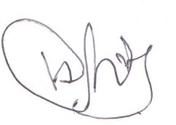

**Vijay R. Chaudhari**

**ANNEXTURE I:**

Nanophase material synthesis, characterization and tuning and investigating their properties in terms of their shape, size, composition and Electro-catalysis/catalysis mostly through electrochemical and optical methodologies is my main research interest. I have synthesized nanomaterials of various size, shapes and compositions through chemical, physical, microwave and electrochemical techniques and investigated their electrochemical, optical and electrocatalytic/catalytic properties in view of electronic and surface structures. Briefly, we understood their behavior in terms of electron transfer capability, impact of surrounding medium, their own surface structure variation, local environment barrier.

Presently I am working on design of efficient, durable and cost-effective catalyst and electro-catalyst for electrochemical energy harvesting applications and also design the synthetic strategy in continuous flow to achieve high production rate. Briefly, we have designed the novel sol-gel method for the deposition of ultrafine transition metal nanoparticles with control morphologies on metal oxide supports those showed high electro-catalytic/catalytic performance, durability and turn over frequency. Moreover, transition metal based nano-alloys have been synthesized with control compositions. Using these materials we are trying to understand the fundamentals of electrochemical hydrogen evolution reaction (HER) for the improvisation of HER electro-catalysis using cost-effective electro-catalyst materials. Currently, our major research devotion is towards electro-chemical energy harvesting processes.

In addition to electrochemical investigations for and on nano-dimensional materials, I also have worked on some projects related to redox behavior of systems that are of fundamental and environmental interest. Cylic voltammetry, chrono techniques, impedance methods, the conventional analysis procedures, besides simulation and convolutive transformation of the associated data are the main methods that I have used in such investigations. Some of the examples related to such work are our studies, the electrocatalytic behavior of hydroquinone in un-buffered aqueous medium at Au electrode and determination of mechanistic aspects of nitrate ion reduction at Ag electrode. In the later work we have successfully demonstrated the use of cyclic voltammetry in determination of bond energy for electron transfer initiated bond cleavage reactions.

I am also working on preparation, characterization and understanding the behavior of self assemble monolayer (SAM). Main focus of this study was to improve the order of SAM, investigate the mechanism of SAM exchange process and understand the optical nature of adsorbate-substrate interface of SAM build up from Thiols and Selenides. Our main interest is to design the robust functional surfaces for anchoring pattern nano-assemblies for electronic and catalytic/electro-catalytic applications. We explored our research findings through various analytical techniques *viz*. UV-visible, Fluorescence, Infra-red (FTIR/RAIRS), Photoelectron (NEXAFS, XPS), Raman, ellipsometry spectroscopy, X-ray diffraction, light scattering, various microscopies (TEM/SEM/STM), thermo-gravimetric and electroanalytical techniques.